**ALL ABOUT CONTACT LENSES**

If you are new to contact lenses, your first step in finding the right pair is to see an eye doctor for an eye exam and contact lens fitting. Contact lenses, like eyeglasses or vision surgery, can correct your nearsightedness, farsightedness and astigmatism. Among Americans who need vision correction, about 20 percent wear contact lenses.

an image of contacts

While some people enjoy making a fashion statement with eyeglasses, others prefer their appearance without them. Contact lenses offer the ability to be glasses-free without expensive vision surgery. Contacts also provide a wider field-of-view than glasses, which is great for sports.

Contact lenses have been around for more than a hundred years, and today just about everyone can wear contact lenses. If you were told in the past that you couldn't wear contacts, odds are you can today. There are more convenient and healthy contact lens options than ever, including many contact lenses that can correct astigmatism.

In the United States, contact lenses are considered medical devices, and they must be prescribed and properly fitted by an eyecare professional. Your eye doctor will evaluate your visual needs, your eye structure, and your tears to help determine the best type of contact lenses for you.

During the exam, your doctor will make sure your eyes are healthy enough to wear contact lenses and will counsel you about what to expect when wearing contacts. Next comes the contact fitting itself. Detailed measurements of your eyes are taken, and trial lenses are applied to achieve the best possible fit and determine if you can comfortably wear contacts.

A contact lens fitting takes more than a single visit to the eye doctor. You will be asked to return for follow-up visits to make sure the lenses continue to fit properly and remain comfortable after prolonged periods of wear. In some cases, changes of lens size or design are needed before the fitting process is complete.

**Contact Lens Designs**

Many lens designs are available to correct various types of vision problems:

Spherical contact lenses are the most common design. Spherical soft lenses correct nearsightedness and farsightedness. Spherical GP lenses can correct nearsightedness, farsightedness and astigmatism.

Toric lenses (soft and GP) have multiple lens powers to correct astigmatism.

Bifocal and multifocal contact lenses (soft and GP) contain different zones for near and far vision to correct presbyopia.

Orthokeratology GP lenses are specially designed to reshape the cornea during sleep, providing lens-free daytime wear.

GP lenses are specially designed to reshape the cornea during sleep, providing lens-free daytime wear.

More Contact Lens Features

Colored Lenses. Soft contact lenses are available in colors that can enhance the natural color of your eyes — to make your green eyes even greener, for example. Other colored soft lenses can change the color of your eyes entirely — from brown to blue, for example.

Multifocal & Bifocal contacts for astigmatism. These are advanced soft contacts that correct both presbyopia and astigmatism, so you can remain glasses-free after age 40 even if you have astigmatism.

Special-Effect Lenses. Also called theatrical, gothic, Halloween or costume lenses, these soft lenses take coloration one step further to make you look like a cat, a zombie, or another alter-ego of your choice.

Prosthetic Lenses. Colored contact lenses can also be used for more medically oriented purposes. People with disfigured eyes, as a result of accidents or disease, can use a custom-colored soft lens to mask the disfigurement and match the appearance of their normal eye.

Custom Lenses. If conventional contact lenses don't seem to work for you, you might be a candidate for custom contact lenses that are made-to-order for your individual eye shape and visual needs.

UV-inhibiting Lenses. Some soft contact lenses help protect your eyes from the sun's ultraviolet rays that can cause cataracts and other eye problems. But because contacts don't cover your entire eye, you still should wear UV-blocking sunglasses outdoors for the best protection from the sun.

Hybrid Lenses. One brand of lenses features a GP center with a soft outer skirt, providing wearers with both the crisp optics of a rigid lens and the comfort of a larger, soft lens.

Scleral Lenses. Large-diameter gas permeable lenses called scleral contact lenses are specially designed to treat keratoconus and other corneal irregularities, as well as presbyopia.

Myopia Control Contacts. Special contact lenses are being developed to slow or stop the progression of nearsightedness in children.

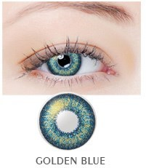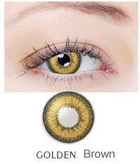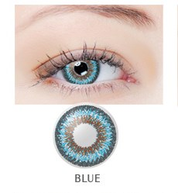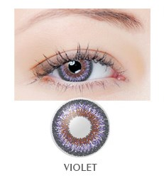

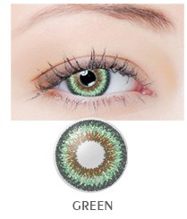

**Contact Lens Problems and Irritations**

Common irritation comes along with wearing contact lenses, but how do you know if this irritation is something more serious? There are four common eye irritations that can be caused by wearing contact lenses, including:

Red, itchy eyes – Contact lenses need to be properly taken care of with regular cleaning and removal in order to prevent a bacterial infection. Contact lenses can easily trap secondhand cigarette smoke, pollen, dust, smog and makeup. The buildup of these irritants can cause itchy, red or burning eyes and lead to pink eye (conjunctivitis).

Dry eyes – Soft contact lenses all contain a varying amount of water, and the more water a lens has, the more easily it loses that water. When the lens evaporates water, it will react by pulling moisture from the eye, which causes the eye to become dry. Although dry eyes is a fairly common condition, those who suffer from it on a constant basis could have dry eye syndrome. This condition is caused by low production of natural tears or too much water evaporation of the watery tear layer. Age, change in hormones or an autoimmune disease is all possible causes for low tear production.

Sensitivity to light – Wearing contacts too long can lead to corneal ulcers and corneal abrasions that scar the cornea and make the eye sensitive to light. Along with wearing contacts for too long, dirt, metal particles, sand and certain medicines are all possible causes of corneal abrasions.

Blurry or cloudy vision – When wearing dirty or damaged contact lenses, vision may become blurred or cloudy. In more serious cases, glaucoma, macular degeneration or cataracts could be the reason behind blurred vision, which is why it is important to see your eye doctor immediately if you begin to experience changes in your vision.

